Topic name: RTO Database

Description: RTO database consists of information about vehicles and their owner and about officers who were assigned to which vehicle.

**Entity Relationship Diagram**

**Our database tables.**

**1.RTO Table;**

RTO table consists of details of vehicle which has been passed by RTO. It consists of Registration ID, vehicle owner name, address, Registration date, RTO charges, car ID and ID of the officer who have passed the vehicle.

And here are the entries….

**2.Car Details table;**

Car details table is linked to RTO table. It consists of information about the cars which has been through RTO.

And here are the entries…

**3.Officer table;**

Officer table consists of information about RTO officers. This helps to maintain a record of which officer was available and when, and who’s handling which case.

And here are the entries…

**Let us go through some of subquerys;**

1. To find all the vehicles which has been passed by senior officers.

select Owner_Name,Owner_Address,Registeration_Date from RTO where Officer_Id in (select Officer_Id from Officer where Designation="Senior Officer");

1. To find a specific vehicle type which has been passed.

select Owner_Name,Owner_Address,Registeration_Date,RTO_Charges from RTO where Car_Id in(select Car_Id from Car_Details where Car_Type="SUV");

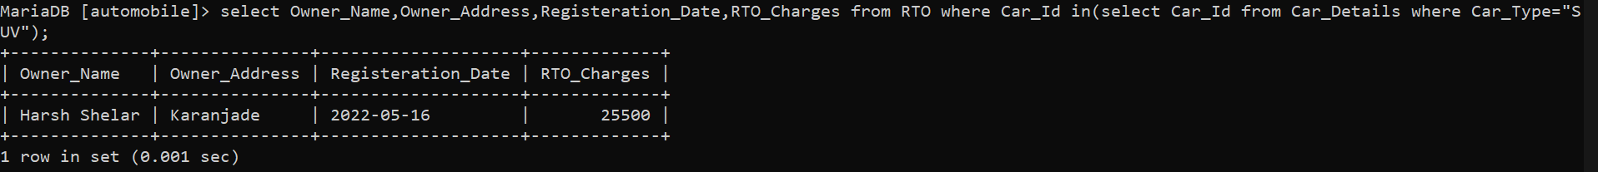

**Let us go through some of joins;**

1. To find which officer has passed whose car. (Left Join)

select RTO.Owner_Name, Officer.Officer_Name from RTO left join Officer on RTO.Officer_Id=Officer.Officer_Id order by Officer_Name;

1. To find the car name and type which has been passed by RTO. (Inner join).

select RTO.Owner_Name, Car_Details.Car_Name from RTO inner join Car_Details on RTO.Car_Id=Car_Details.Car_Id;

1. To find out car ID, owner name and address. (Right join)

select Car_Details.Car_Id, RTO.Owner_Name, RTO.Owner_Address from Car_Details right join RTO on Car_Details.Car_Id=RTO.Car_Id;

**Let us go through some of views;**

1. This view shows car name, car type and insurance provider for cars whose price is greater than 50,00000.

create view Insurance_Company as select Car_Name,Car_Type,Insurance_Provider from Car_Details where ExShowroom_Price>=5000000;

